SkyTeam’s
Multiplayer
Connection Guide

The following are prerequisites to connecting to a multiplayer server:

Microsoft Flight Simulator X has been installed.
Service Pack 2 or Acceleration for Microsoft Flight Simulator X have been installed (most servers require these updates). Acceleration is a payware product, but Service Packs 1 and 2 are free. Download them here.
You have the IP address of the server you wish to connect to.

To get connected to a multiplayer server, start FSX and from the main screen, select the "Multiplayer" tab. Then, follow these six steps.
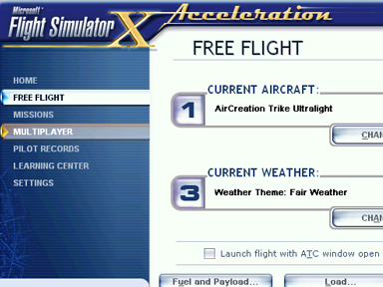
1. Select the "Local Network (LAN)" radio box (not GameSpy).

2. Enter a distinct username in the "Player Name" box. The default value in that box will be "Player", so make sure to change that to something meaningful.
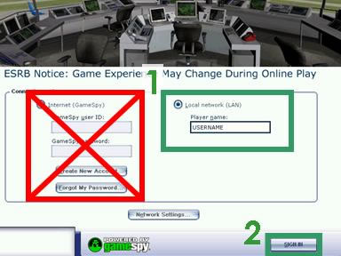

3. Click "Sign In", and then "Connect Directly".
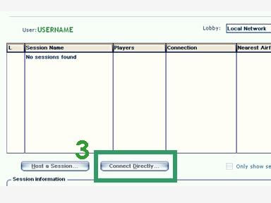

4. When prompted, enter the IP address of the server you wish to connect to.

5. Click "Find Sessions". In a few moments, you will either enter the server or be prompted to enter a password.
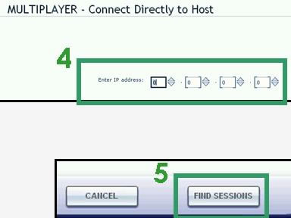

6. You're connected... and should now be in the session's Briefing Room. You can now set up your aircraft and participate in the server.
